**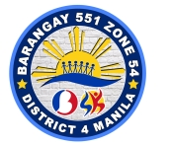 *Republic of the Philippines***

**BARANGAY 551 ZONE 54**

**DISTRICT IV, SAMPALOC, MANILA**

OFFICE OF THE BARANGAY CHAIRMAN



**ARMINDO E. LOYOLA**

***Barangay Chairman***

***Barangay Kagawad***

**LOURDES I. BERNARDO**

**NIDA D.C. MERCADO**

**CECILE L. MORALES**

**JOEL S. LIMBO**

**HERBERT G. SANTIAGO**

**VIRGINIA M. MADARANG**

**ALVIN M. BELGICA**

***SK Chairwoman***

**KYLA-LEI MANALESE**

***Brgy. Secretary***

**ROWENA D. CRESINES**

***Brgy. Treasurer***

**CARMELITA S. LIMBO**

***Brgy. Ex-O***

**Aristotelle B. Sudaria**

**CERTIFICATE OF LOW INCOME**

TO WHOM IT MAY CONCERN:

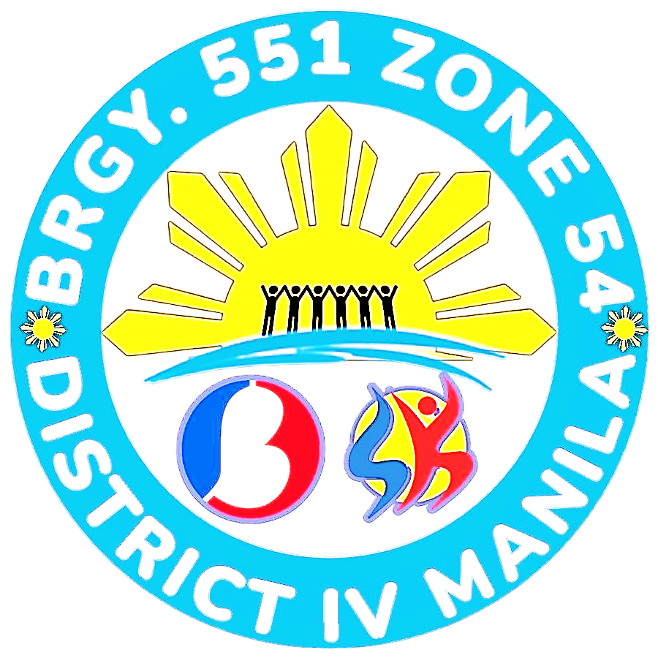

This is to certify that **MA. JOBELLE S. SANTOCILDES** , **37** years old, single, Filipino citizen is a bonafide resident of this barangay with postal address located at **373 SAN DIEGO ST.**, Sampaloc, Manila.

CERTIFY FURTHER that the above-mentioned name generates a low income ( Online Seller ) with a monthly income not exceeding 5,000 pesos which is insufficient for the full sustenance of their family needs.

This certification is hereby issued upon the request of the above-mentioned name to avail of ***Financial Assistance*** under “Ayuda Para sa kapos ang Kita Program (AKAP)” of the Department of Social Welfare and Development (DSWD).

DONE and ISSUED this, 29th day of April2025 at Barangay 551, Sampaloc, Manila.

Approved by:

__________________ ARMINDO E. LOYOLA

*Barangay Chairman*